1.

a) IP address:10.10.127.0/17

Network address: 10.10.0.0

Broadcast address: 10.10.127.255

b) IP address: 10.10.127.0/19:

Network address: 10.10.96.0

Broadcast address: 10.10.127.255

2.

Router A:

|  |  |
| --- | --- |
| Prefix | Next Hop |
| 192.168.3.0/24 | 192.168.2.2 |
| 192.168.13.0/24 | 192.168.12.2 |

Router B:

|  |  |
| --- | --- |
| Prefix | Next Hop |
| 192.168.1.0/24 | 192.168.12.1 |
| 192.168.11.0/24 | 192.168.2.2 |

3. a)

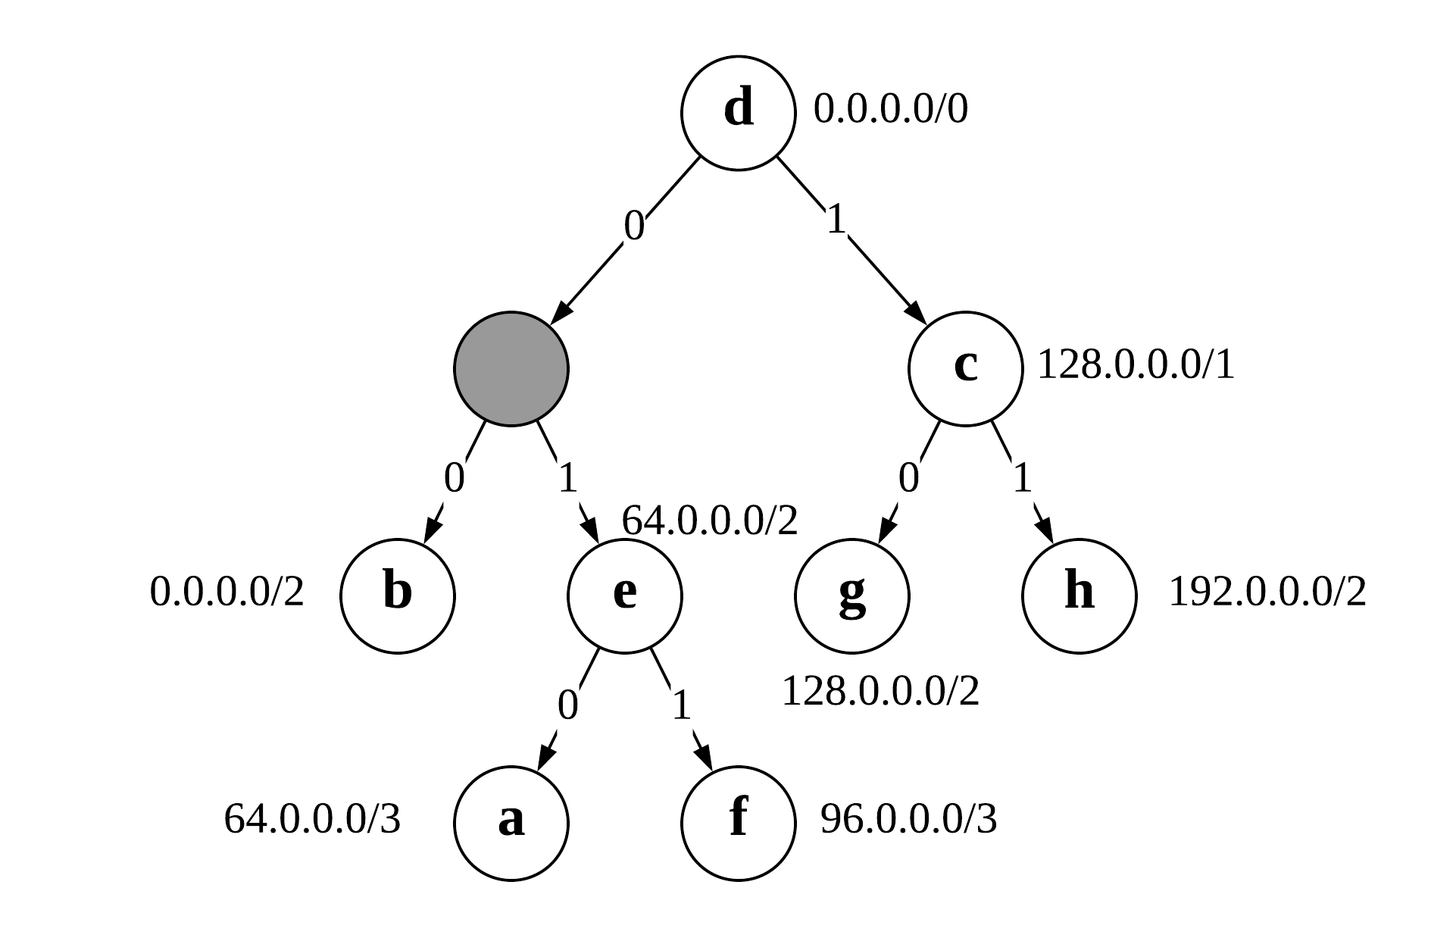Routing table:

|  |  |
| --- | --- |
| Prefix | Index |
| 0.0.0.0/0 | d |
| 0.0.0.0/2 | b |
| 64.0.0.0/2 | e |
| 64.0.0.0/3 | a |
| 128.0.0.0/1 | c |
| 96.0.0.0/3 | f |
| 128.0.0.0/2 | g |
| 192.0.0.0/2 | h |

b) 64.0.0.1/32 is included in index ‘a’, index ‘e’ and index ‘d’.

c) 192.0.0.1/32 is included in index ‘h’, index ‘c’ and index ‘d’.

d) & f) 